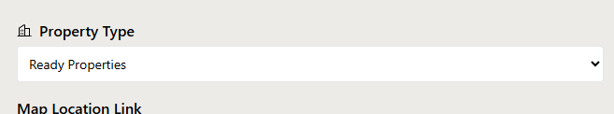Ready Properties agr koi select karain to option ay   
Apartment   
Villas   
Townhouse & More

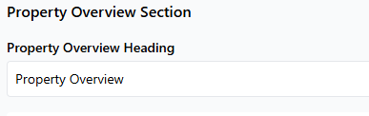

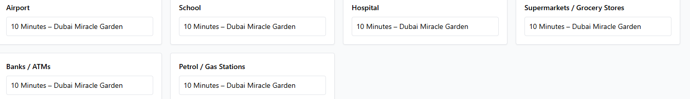  
  
  
  
  
  
  
Property Overview ke heading fix kr dain, field he nahi show karwain.  
  
  
Hamain agar multiple school yeh hopistal banks wagaira add krny hai to kaisay karain gy ap ny sirf 1 he box rakha howa hain.  
  
  
  
  
  
  
  
  
  
  
  
  
  
  
**These are the fields for SEO Section**  
  
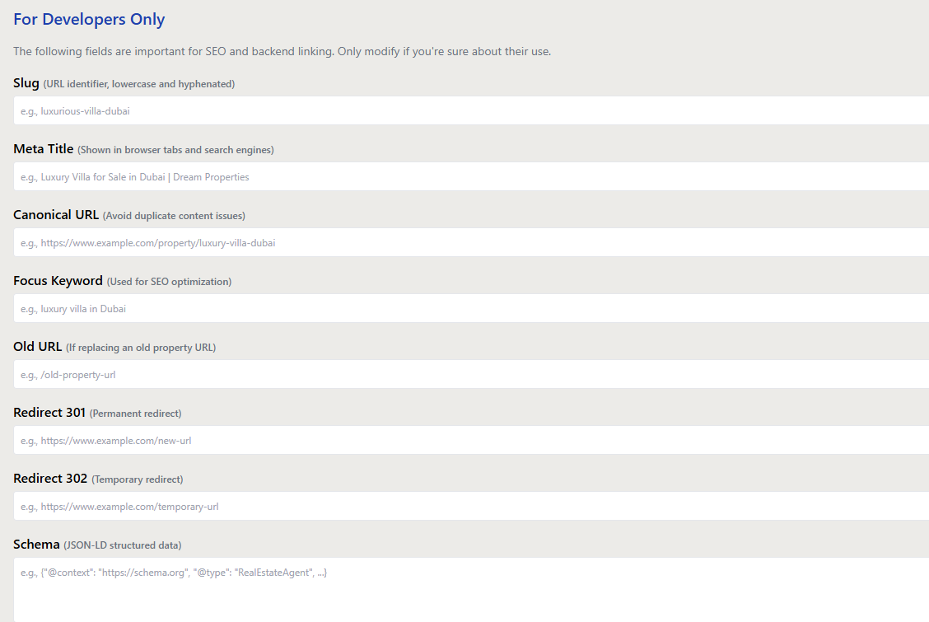Slug: use the property name in the slug ex: gharbi-2-residences/  
  
Meta Title (60 Character): Use Property Name then Area or Community & Developer Name,   
ex: Gharbi 2 Residences at JVC by Rabdan Developments  
  
Meta Description (160 Character): Your focus keyword should be in the meta description and it should not be above then 160 character.  
  
Canonical: use the property name in the slug ex: gharbi-2-residences/  
  
Focus Keywords: Use the property name as focus keyword  
  
  
**These are fields for developer section**  
  
Old Redirect: not useful for the agents  
Redirection 301: not useful for the agents  
Redirection 302: not useful for the agents  
Schema: not useful for the agents

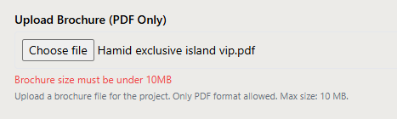

PDF File size should be under 20Mb’s